**Research on International Currency Exchange**

*Purpose*

Since Bitcoin and other cryptocurrencies are sometimes viewed as currencies, I want to use this analogy of a more established market like the international exchange currency to better understand the market of cryptocurrencies.

According to Investopedia, Forex is an exchange platform that has little to no regulation to exchange currency.

*“Unlike stocks, futures or options, currency trading does not take place on a regulated exchange. It is not controlled by any central governing body, there are no clearing houses to guarantee the trades and there is no arbitration panel to adjudicate disputes. All members trade with each other based on credit agreements. Essentially, business in the largest, most liquid market in the world depends on nothing more than a metaphorical handshake.”*

Forex might seem like a crazy platform, but there is some unspoken rules established that keep the exchange run smoothly.

*“At first glance, this ad-hoc arrangement must seem bewildering to investors who are used to structured exchanges such as the NYSE or CME. (To learn more, see Getting To Know Stock Exchanges.) However, this arrangement works exceedingly well in practice; because participants in FX must both compete and cooperate with each other, self regulation provides very effective control over the market. Furthermore, reputable retail FX dealers in the United States become members of the National Futures Association (NFA), and by doing so they agree to binding arbitration in the event of any dispute. Therefore, it is critical that any retail customer who contemplates trading currencies do so only through an NFA member firm.”*

*Read more: Top 7 Questions About Currency Trading Answered https://www.investopedia.com/articles/forex/06/sevenfxfaqs.asp#ixzz57xwzC1s1*

This market resembles the cryptocurrency market somehow due to the belief in efficiency of self-regulation, and nature of the transactions.

Due to Investopedia, 20% of the market volume is used for cooperate needs, for example, for payroll, payment for goods, and foreign vendors,… and the other 80% are speculative, which essentially firms or individuals trying to make a profit.

*Currencies Traded in the forex market*

7 most liquid currency pairs in the world:

Major 4’s:

* EUR/USD (euro/dollar)
* USD/JPY (dollar/Japanese yen)
* GBP/USD (British pound/dollar)
* USD/CHF (dollar/Swiss franc)

3 commodity pairs (in other words, traded at high volumes and very liquid) :

* AUD/USD (Australian dollar/dollar)
* USD/CAD (dollar/Canadian dollar)
* NZD/USD (New Zealand dollar/dollar)

**Planning**

As a result, I think similarly to these currency trading, Bitcoin and other cryptocurrencies’ traders are mainly in the market for speculation and hoping to make a profit as supposed to believing that they can spend their Bitcoin somewhere.

However, recently there is a huge drop in Bitcoin’s price and in the market in generally, so some people think this will be the point where some speculation may wear off and the underlying transactional demand will be more apparent. So a way that we might be able to figure out if the speculative or transactional demand is bigger is to regress the Bitcoin price on:

* Expected price tomorrow, or number of people buying Bitcoin, or google search query for Bitcoin (speculative)
* Number of vendors accepting Bitcoin (transactional)

And whichever has a higher correlation will likely be the main driver of demand

* Exchange rate/ return model – futures

<https://www.dailyforex.com/forex-articles/2009/05/7-reasons-to-trade-forex/965>

**Cointergration test for Bitcoin, Litecoin and Etherem price**

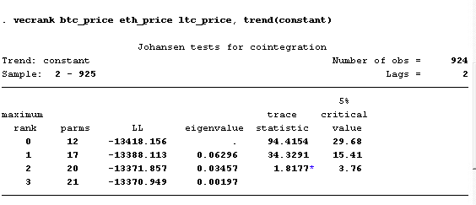

**The test result indicate that there is 2 cointegrations among these variables (btc, ltc, eth price)**

The Dickey Fuller test all returns non-stationary for all these variable. So I tried to calculate if the different between btc_price – eth_price (the closet candidate for btc_price). It is also non-stationary.

The same goes for btc_price – ltc_price

**Robert Shiller**

Irrational exuberance

Measuring bubble expectation

From efficient market theory to behavior finance

BTC_price – non-stationary

BTC_price first difference, stationary

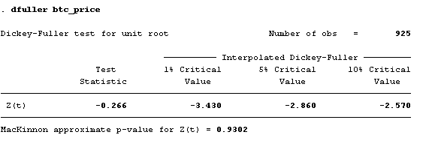

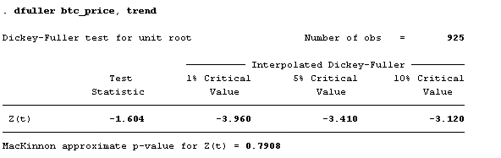

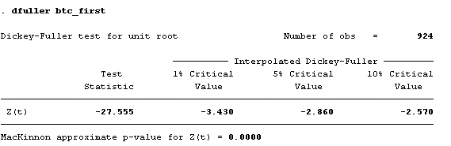

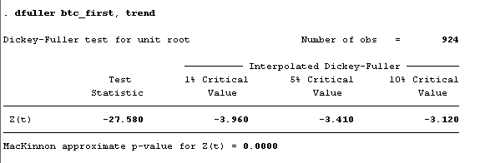

Lag 3 times (Building on the work of Tsay (1984) and Paulsen (1984), Nielsen (2001) has shown that the methods implemented in varsoc can be used to determine the lag order for a VAR model with I(1) variables.

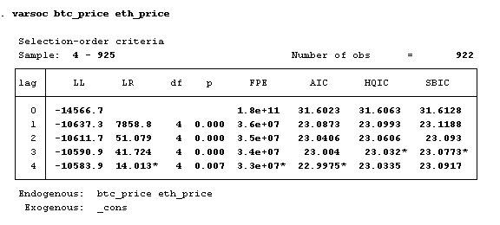

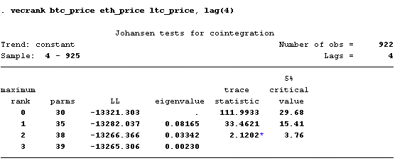

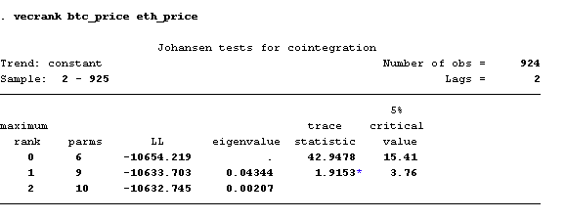

Bivariate Cointegration

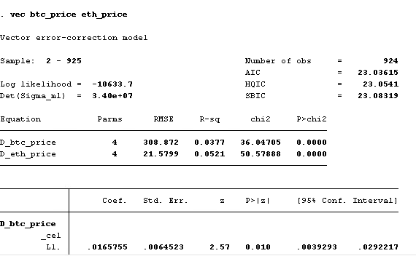

The estimate of the coefficient [D dallas]L. ce1 is −.3. Thus when the average housing price in Dallas is too high, it quickly falls back toward the Houston level. The estimated coefficient [D houston]L. ce1 of .5 implies that when the average housing price in Dallas is too high, the average price in Houston quickly adjusts toward the Dallas level at the same time that the Dallas prices are adjusting.

D-btc_price (L.cel is 0.016…) ~> When ETH price is high, BTC price also increases

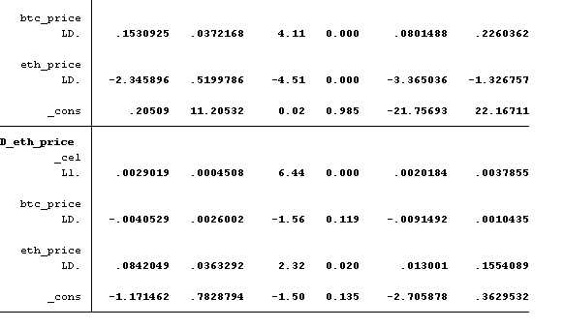

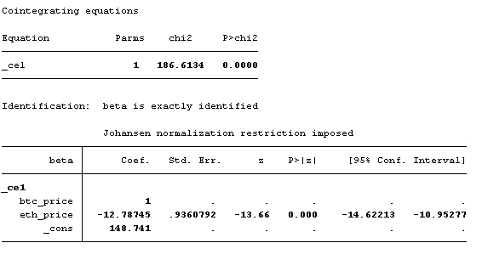

But there’s serial correlation

